**DESIGN DOCUMENT APPLIED PROJECT 2019**

**STAKEHOLDERS**: **Supervisor** : Brian McGinley.

**Student Name : Raja Naseer Ahmed Khan.**

**PROJECT DETAILS:**

Project Title : Multi Player Tank/Person Shooter

**Contents in Document**

1. Introduction.

2. System Requirements.

3. Technology for Development.

4. Architecture of the solution.

5. Design Methodology

6. Testing plans.

7. Extras (Part 2) or 2nd Semester

**1. Introduction**

This game is based on simple architecture of Babylon.js, WebGL, Node and Socket.io but can be challenging to make as C.P.U. player and enemies will be added (A.I). we must make a system, which randomly generates enemies in different locations, as well which will follow our player. and let the user play in multiplayer mode with other players online(2nd Part). There are plenty of videos on YouTube. Difficulty level will be increased after each stage generated by developer either timed or targeted. Enemy speed or quantity.

**2. System Requirements**

Connection to Internet.

Browser Supports WebGL Graphics.

**3. Technology Used During Development.**

i. Babylon.js, WebGL, JavaScript Scripting with Node, Socket.io and python http.

ii. Visual Studio Code/ or any Text Editor.

iii. Windows 10 Home Edition.

**4. Architecture of the Solution (Below are Sample Design)**

We need to create start menu scene with music.

Game should look like below.

Tank should shoot projectile (rockets, missile, ammunition) towards enemy to destroy enemy tank, people, or anything get in contact with projectile.

Tank should have health meter in case get hit by enemy projectile.

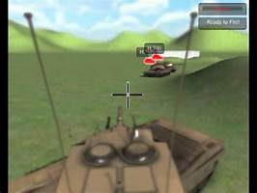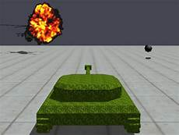

**5. Design Methodology**

Babylon.js is used to Build G.U.I. and Assets and JavaScript is used to build business logic.

Simple technology used for developer to understand. Assets are easily available as well plenty of videos explaining how to use A.I. and network games. Coding won’t be an issue as controls and scripting can be completed watching videos on youtube.com as well.

6. Basic Testing Plans

i. Run on android.

ii. Run on windows 10.

iii. Check each game is loading by buttons on main screen.

iv. Check if play/exit button is working on each game.

v. Check weather shooting/controls are operating as desired.

vi. If multiplayer included check if connection is established with server and

player can join.

7. Extras in Part 2 (2nd Semester)

Multiplayer using heruko and socket.io

References: